 | Pimpri Chinchwad Education Trust’s  Pimpri Chinchwad College of Engineering  (PCCoE)  (An Autonomous Institute)  Affiliated to Savitribai Phule Pune University(SPPU) ISO 21001:2018 Certified by TUV | 
Course: DevOps Laboratory | Code: BIT26VS01
Name: Amar Vaijinath Chavan | PRN: 124B2F001
Assignment 1: Git Installation, Configuration, and Setup Verification.

Aim: To install Git on both Windows and Ubuntu operating systems and configure the global
user environment to establish a functional version control setup.

Objectives:
- To perform a clean installation of Git on multiple platforms.
- To configure global identity settings (Username and Email) required for commit attribution.
- To verify the installation and setup through version control queries and configuration checks.

Theory:

1. What is Git? Git is a distributed version control system (DVCS) that tracks changes in source code during software development. Unlike centralized systems, Git provides every developer with a full copy of the repository history, allowing for offline work and robust branching and merging capabilities.

2. The Importance of Configuration Git configuration is essential because every commit in Git uses this information to identify the author of the changes. These settings are stored in a configuration file (like .gitconfig) and are applied globally across all projects on the system unless overridden locally.

Practical Procedure / Steps:

A. Installation on Ubuntu (Linux)
- Update Package List: Open the terminal and run sudo apt update to ensure your package manager has the latest info.
- Install Git: Execute the command: sudo apt install git
- Confirm Installation: When prompted, type Y and press Enter to complete the process.

B. Installation on Windows
- Download Installer: Go to the official Git website (git-scm.com) and download the 64-bit Git for Windows Setup.
- Run Setup: Double-click the .exe file to start the installation wizard.
- Default Settings: Proceed through the prompts using the default recommended settings (especially for "Adjusting your PATH environment" and "Choosing the default editor").
- Complete Finish: Once the bar reaches the end, click Finish.

C. Configuration (Common for both OS)
After installation, you must introduce yourself to Git. Open your terminal (Ubuntu) or Git Bash (Windows) and run:
- Set Username: git config --global user.name "<username>"
- Set Email: git config --global user.email "<email>"

D. Setup Verification

To ensure everything is working correctly, perform the following checks:
- Check Git Version: git --version
  - Result: Should display git version 2.x.x.
- Verify Configuration Details: git config --list
  - Result: This will list your name and email to confirm they were saved successfully.

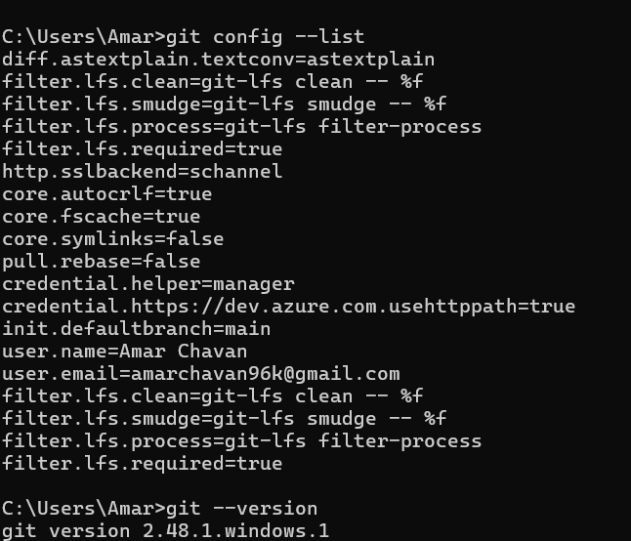
Conclusion

The successful completion of this assignment establishes the foundational environment required for all DevOps activities. By installing Git on both Ubuntu and Windows, we ensured cross-platform compatibility for project development. The global configuration of the username and email is a critical step, as it ensures that every subsequent contribution is correctly attributed to the author within the project's history. Finally, the verification steps confirmed that the Git binary is correctly mapped to the system's path and ready for local and remote repository management.

